ASSIGNMENT-2

**1. JUPYTER NOTEBOOK**

**Question 1**

The contrast of the image is increasing linearly with the increasing value of the clip limit.

Clip Limit = 0.01

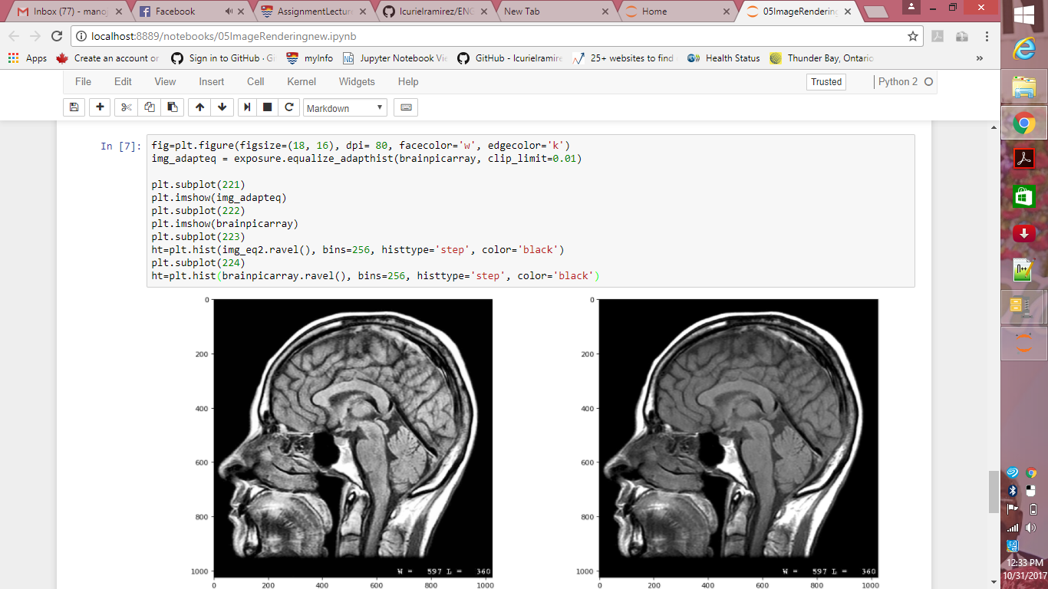

Clip Limit = 0.05

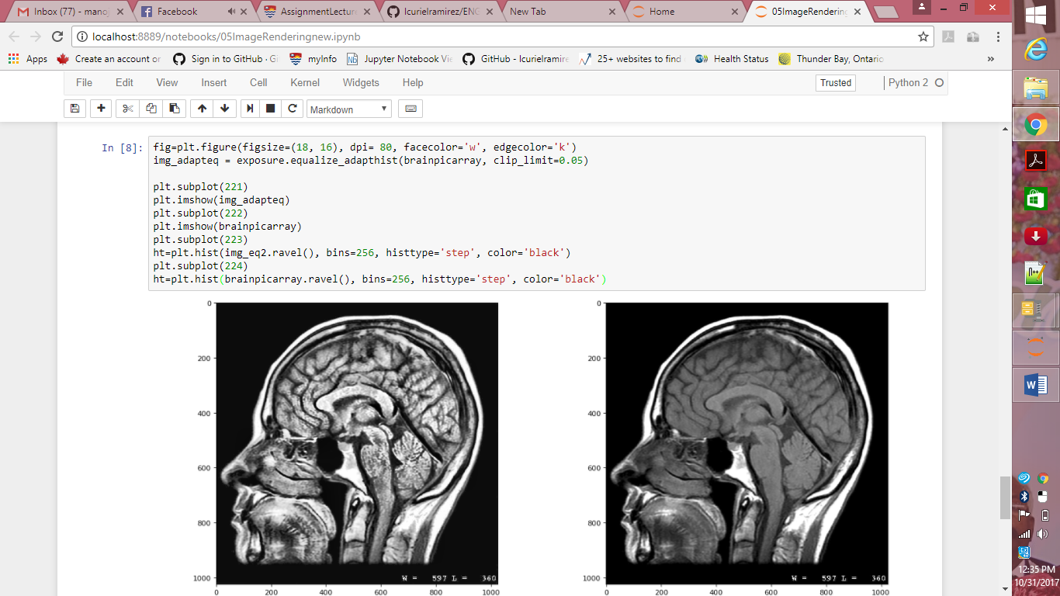

**Question 2**

**Equalize_hist (image*,*nbins=256*,*mask=None)**

**Parameters**

|  |
| --- |
| **image** : array  Image array.  **nbins** : int, optional  Number of bins for image histogram. Note: this argument is ignored for integer images, for which each integer is its own bin.  **mask:** ndarray of Boolean or 0s and 1s,optional  Array of same shape as image. Only points at which mask == True are used for the equalization, which is applied to the complete image. |
| **out** : float array  Image array after histogram equalization. |

**Question 3**

**Equalize_adaphist (image*,*kernel_size=None*,*clip_limit=0.01*,*nbins=256)**

This is for local contrast enhancement that uses histograms computed over different segments of the image. Local details can therefore be enhanced even in regions that are darker or lighter than most of the image.

**Parameters**

**image** : (M, N, [C]) ndarray

Input image.

**kernel_size: integer, optional**

Defines the shape of contextual regions used in the algorithm.

**clip_limit** : float, optional

Clipping limit, normalized between 0 and 1 (higher values give more contrast).

**nbins** : int, optional

Number of gray bins for histogram (“data range”).

**Question 4**

Histogram equalization seems to be less sensitive to noise but does not improve the contrast of subtle changes by much. On the other hand, adaptive histogram equalization is more sensitive to noise but is capable of enhancing subtle changes in the region for image processing purposes.

**2. INVESTIGATION ASSIGNMENT**

**Decorrelation stretching**

**a) What is the technique used for and what is an example of its application?**

Decorrelation stretching enhances the color separation of an image with significant band-band correlation. The exaggerated colors improve visual interpretation and make feature discrimination easier.

The concept of decorrelation can be applied in many fields. In neuroscience, decorrelation is used in the analysis of the neural networks in the human visual system. In cryptography, it is used in cipher design and in the design of hardware random number generators.

**b) Find a function in Python that can provide this functionality. Give the syntax and explain the parameters of this function.**

Basically, there is no inbuilt library function for decorrelation stretch in python. But a user defined function can be built and executed. I have found a page on github where a person has implemented this function.

import numpy as np

import cv2

def decorrstretch(A,tot=None)

orig_shape=A.shape

A = A.reshape((-1,3)).astype(np.float)

cov = np.cov(A.T)

sigma = np.diag(np.sqrt(cov.diagonal()))

eigval, V = np.linalg.eig(cov)

S = np.diag(1/np.sqrt(eigval))

mean = np.mean(A, axis=0)

A -= mean

T = reduce(np.dot, [sigma, V, S, V.T])

offset = mean - np.dot(mean, T)

A = np.dot(A, T)

A += mean + offset

B = A.reshape(orig_shape)

for b in range(3):

if tol:

low, high = np.percentile(B[:,:,b], 100*tol), np.percentile(B[:,:,b], 100-100*tol)

B[B<low] = low

B[B>high] = high

B[:,:,b] = 255 * (B[:,:,b] - B[:,:,b].min())/(B[:,:,b].max() - B[:,:,b].min())

return B.astype(np.uint8)

Whereas we have a in-built decorrelation function in Matlab.

A = multibandread('littlecoriver.lan', [512, 512, 7],'uint8=>uint8', 128, 'bil', 'ieee-le',{'Band','Direct',[3 2 1]});

B = decorrstretch(A);

figure

imshow(B)

title(‘Resulting image’)

**c) Can this particular technique have an application on medical images? If so, which modality uses this enhancement?**

# This image enhancement technique can be used in multispectral chromosome image classification. A region based decorrelation stretch can be used for this purpose. We can enhance the classification ratio based on a region based decorrelation stretch transform. Using the decomposition of the multichannel image into homogenous regions, the classification results will be improved after the application of the decorrelation stretch transform.

**d) Provide a scientific paper that uses or proposes this image enhancement technique**

<http://www.gjesr.com/Issues%20PDF/INIT%20Conference/16.pdf>

**REFERENCES**

1. [https://www.mathworks.com/help/images/enhance-color-separation-using-decorrelation-stretching.html?s_tid=gn_loc_drop](%20https:/www.mathworks.com/help/images/enhance-color-separation-using-decorrelation-stretching.html?s_tid=gn_loc_drop)

2. <https://github.com/lukassparrow/decorrstretch/blob/master/ds.py>

3. <https://waseda.pure.elsevier.com/en/publications/application-of-decorrelation-stretching-method-to-hyperspectral-f>

4. <http://ieeexplore.ieee.org/document/4712040/>